Microwave Design Services

When Fiber Can’t Reach — The Network Still Has to Perform

Style

Hero: When Networks Can’t Wait for Fiber, We Engineer Certainty.
Hero Section: We design carrier-grade microwave networks for environments where fiber is delayed, impractical, or financially uncertain. We treat our customers as partners and approach every network as if we own its outcome.

Delays, terrain, permitting, and environmental constraints often slow deployments. In many cases, teams are also unsure whether a large fiber investment will deliver the expected return. Yet the expectation remains unchanged: high availability, predictable performance, and timely delivery.
Whether supporting a 5G rollout, connecting critical infrastructure, or extending networks into remote locations, waiting years or committing to uncertain ROI is rarely an option.
At SpiroLink, we help bridge this gap by designing carrier-grade microwave networks that deliver resilience and performance where fiber alone is delayed, impractical, or financially uncertain.
Why Network Rollouts Get Stuck
- Permits, site access, and regulatory approvals often take far longer than expected, even after technical designs are complete.
- Fiber build timelines can stretch into years, and teams are not always confident the investment will deliver the expected return.
- Urban density, difficult terrain, water crossings, and protected environments can make trenching impractical or unacceptable.
- Networks built on a single underground path remain exposed to physical disruption, leaving little room for true resilience.
When designed properly, microwave helps move projects forward without becoming a temporary or risky compromise.

Where We Take Responsibility

Style:

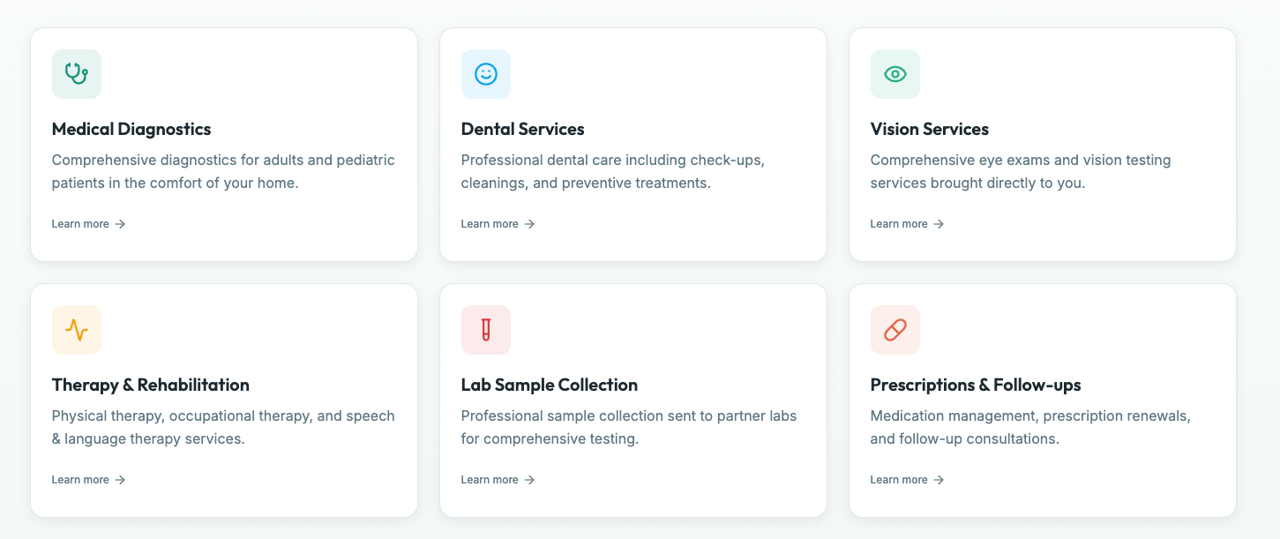
Internet Service Providers (ISPs)
ISPs face constant pressure to expand coverage while controlling costs and maintaining service quality. We help design microwave connectivity where fiber is delayed or impractical, enabling steady growth without introducing instability or future rework.

Utilities & Energy
Utility networks carry operational data where outages can affect safety, compliance, and service continuity. We design microwave connectivity for grids, substations, pipelines, and renewable sites with availability and resilience as the priority, ensuring critical infrastructure remains connected under all conditions.

Transportation & Infrastructure
Transportation systems depend on continuous communication across wide, distributed environments. We design microwave networks that support railways, highways, ports, and transit systems, ensuring monitoring and control remain reliable even in harsh terrain and weather.

Healthcare
Healthcare networks support systems where delays or outages directly impact patient care. We design microwave connectivity for hospital campuses, remote clinics, and telemedicine environments so critical services remain available when fiber access is limited or delayed.

Enterprise & Corporate Networks
Enterprises often need reliable connectivity between campuses, remote offices, and industrial facilities where fiber access is constrained. We design microwave networks that integrate smoothly with enterprise IT environments, delivering stable connectivity without operational surprises.

Did You Know? (Technical Microwave Insights)

Style
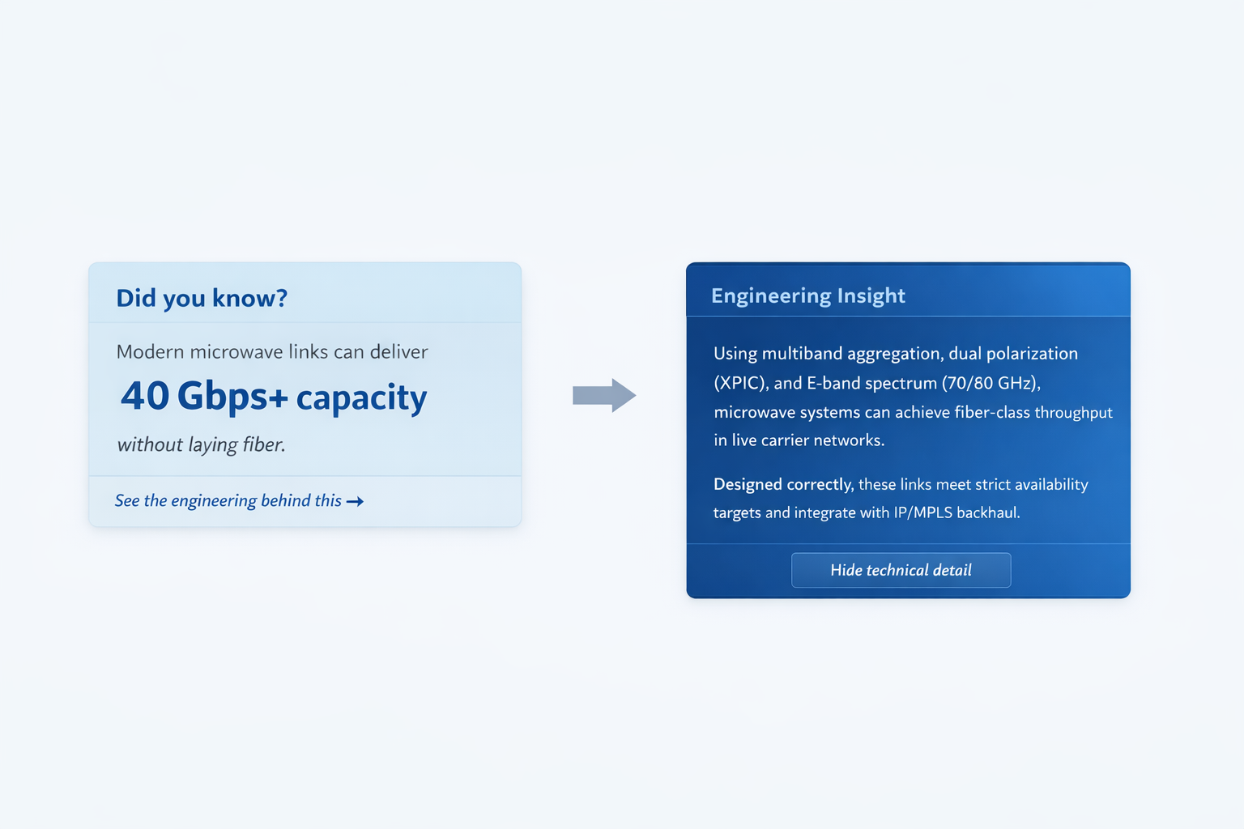

Card 1
Did you know?
Modern microwave links can deliver 40 Gbps+ capacity without laying a single fiber strand.

Card (Reveal – Technical Insight)
Using multiband aggregation, dual polarization (XPIC), and E-band spectrum (70/80 GHz), microwave systems can achieve fiber-class throughput in live carrier networks.
When engineered correctly, these links meet strict availability targets and integrate seamlessly with IP/MPLS backhaul.

Card 2 — nLOS / Near-LOS Reality

Card (Front – Teaser)
Did you know?
Microwave links don’t always require perfect line-of-sight.

Card (Reveal – Engineering Insight)
With near-line-of-sight (nLOS) design, diffraction, reflections, and advanced link budgeting can be used to close paths once considered impossible.
Careful Fresnel clearance analysis and adaptive modulation allow stable operation even in constrained terrain.

Card 3 — MIMO & Polarization Gain

Card (Front – Teaser)
Did you know?
Microwave uses MIMO and polarization techniques similar to advanced wireless systems.

Card (Reveal – Engineering Insight)
Modern microwave radios use dual polarization and XPIC (Cross-Polarization Interference Cancellation) to transmit parallel data streams on the same frequency.
This effectively doubles capacity without consuming additional spectrum.

Card 4 — Latency Advantage

Card (Front – Teaser)
Did you know?
Microwave can sometimes deliver lower latency than fiber.

Card (Reveal – Engineering Insight)
Radio waves travel directly through air along the shortest physical path, while fiber routes often follow indirect rights-of-way.
For certain topologies, microwave introduces fewer hops and lower end-to-end latency than long, circuitous fiber paths.

Card 5 — Bandwidth Is Not Fixed

Card (Front – Teaser)
Did you know?
Microwave bandwidth adjusts dynamically — it doesn’t fail suddenly.

Card (Reveal – Engineering Insight)
Using adaptive modulation and coding (AMC), microwave links gracefully reduce throughput under rain or atmospheric stress instead of dropping completely.
This allows services to degrade predictably rather than catastrophically.

Card 6 — Point-to-Point Isn’t Just “Backhaul”

Card (Front – Teaser)
Did you know?
Microwave solves small, practical problems — not just large networks.

Card (Reveal – Engineering Insight)
Short point-to-point links are often used to connect warehouses, farms, barns, industrial yards, or isolated buildings where trenching makes no economic or environmental sense.
These links can be deployed quickly and removed or upgraded without permanent impact.

Card 7 — Inside Controlled Environments

Card (Front – Teaser)
Did you know?
Wireless links are sometimes used inside data centers and campuses.

Card (Reveal – Engineering Insight)
In controlled environments, short-range wireless links are used for temporary interconnects, rapid expansion, or redundancy paths where cabling is disruptive or slow.
This is especially useful during migrations, upgrades, or phased builds.

Card 8 — Microwave Is Often Primary, Not Backup

Card (Front – Teaser)
Did you know?
Microwave frequently carries primary live traffic, not just backup paths.

Card (Reveal – Engineering Insight)
In many regions, microwave backhaul supports live 4G/5G traffic, enterprise services, and utility control systems with strict availability targets.
Its reliability depends on engineering discipline, not the medium itself.

Let’s Talk Before You Commit.
Not every network problem needs a build.Sometimes it needs clearer thinking before committing.
- Free initial consultation
- Network feasibility assessment
- Project scoping and quotation
- Technical discussions with our engineering team
- ROI and rollout risk considerations
[Contact Us] [Request a Quote] [Schedule Consultation]

Frequently Asked Questions

Q: Do you work alongside our existing vendors or teams?
A: Yes. We regularly work as an extension of internal teams and alongside existing vendors, focusing on design quality, integration, and long-term performance rather than replacing established relationships.

Q: Is microwave intended as a temporary or permanent solution?
A: Microwave can be engineered as either. When designed correctly, it often serves as a long-term primary path or a resilient complement to fiber, not just a stopgap.

Q: Can you review or optimize an existing microwave or fiber design?
A: Yes. We frequently assess existing designs to identify performance risks, integration gaps, and opportunities for improvement before changes are committed.

Q: Do you support hybrid fiber–microwave architectures?
A: Absolutely. Many modern networks rely on hybrid designs, and we specialize in integrating microwave cleanly with fiber and IP/MPLS environments.

Q: Are your services vendor-neutral?
A: Yes. Our recommendations are based on technical fit, operational requirements, and long-term outcomes — not vendor alignment.
Q: Do you provide installation services? A: We focus on design and engineering services, but provide comprehensive implementation support and can recommend qualified installation partners.
Q: Can you help with frequency licensing? A: Yes, we provide frequency coordination services and prepare all necessary documentation for regulatory applications.
Q: What geographic areas do you serve? A: We work with clients globally and have experience with regulatory frameworks worldwide.

